FINANCIAL TRANSACTION AND LOAN ANALYSIS DASHBOARD
P.Mothika
B.Com Fintech and AI
E25FA029

Introduction
Power BI is a business intelligence and data visualization tool developed by Microsoft. It helps users transform raw data into meaningful information through interactive reports, charts, tables and dashboards.
For this project, a Financial Transaction and Loan Dataset was used to create an interactive Finance Overview Dashboard using Microsoft Power BI. The dashboard focuses on financial information such as active loans, total transaction value, customer count and transaction types.
The main purpose of the dashboard is to analyse financial transactions, understand transaction patterns, monitor loan-related information and examine customer activity. KPI cards, charts, a transaction summary table and interactive slicers are used to present financial information clearly and support better analysis.
Objectives of the Project
The major objectives of this project are:
· To analyse financial transactions using Microsoft Power BI.
· To create an interactive financial dashboard.
· To monitor the number of active loans.
· To analyse the total value of financial transactions.
· To understand the number of customers included in the dataset.
· To compare transactions across different transaction types.
· To identify transaction patterns over time.
· To analyse account types and their contribution to financial activity.
· To provide interactive filtering based on year, account type and transaction type.
· To present financial information in a simple and meaningful visual format.

KPI cards are used to display important financial indicators at the top of
the dashboard. They provide a quick summary of the overall financial data
without requiring users to examine each chart individually.
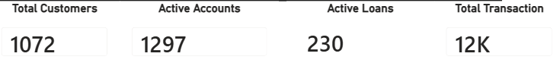

Dashboard Components and Visualizations

The dashboard contains four KPI cards:
- Total Customers: Displays 1,100 customers, providing an overview of the
customer base represented in the dataset.
- Active Accounts: Displays 1,297 active accounts, indicating the number of
accounts classified as active.
- Active Loans: Displays 239 active loans, helping users understand the
number of loans currently classified as active.
- Total Transaction Value: Displays approximately ₹125.19 million as the
total transaction value, summarizing the value of transactions included in
the analysis.
- These KPI cards make it easier to understand the main figures at a glance.
They also provide a starting point for further investigation using the charts
and detailed reports
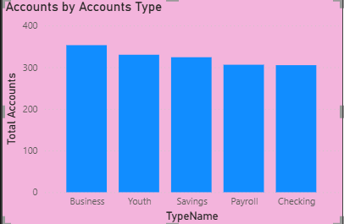
A column chart is used to display the distribution of accounts across
five account types: Business, Youth, Savings, Payroll, and Checking. The
horizontal axis represents the account type, while the vertical axis represents
the total number of accounts.

This visualization helps compare the number of accounts in each
category. From the dashboard, Business accounts appear to have the highest
count, while Payroll and Checking accounts show comparatively lower counts.
The chart provides a quick understanding of how accounts are distributed
across different categories.
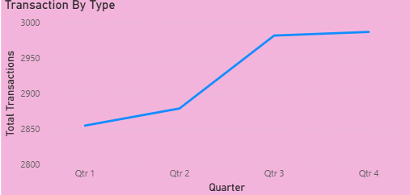
A line chart is used to represent monthly transaction activity from
January to December. The horizontal axis shows the months, while the
vertical axis displays the total transactions represented by the selected
measure.
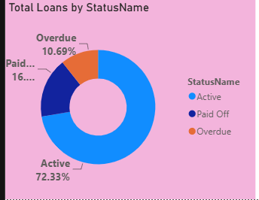
A doughnut chart is used to display the distribution of loans based on
their status. The three categories shown are Active, Paid Off, and Overdue.
The chart indicates that approximately 72.42% of loans are Active,
17.27% are Paid Off, and 10.3% are Overdue. The active category forms the
largest portion of the chart, while overdue loans represent a smaller but
important portion of the distribution.

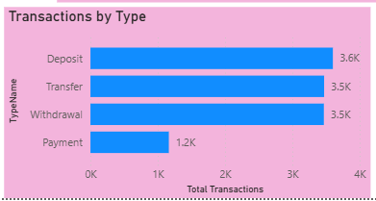
A horizontal bar chart is used to compare the number of transactions
across four categories: Deposit, Transfer, Withdrawal, and Payment.
The chart shows that Deposits have the highest transaction count, at
approximately 15.1K. Transfers and Withdrawals have counts of around
14.8K and 14.7K respectively, while Payments have a comparatively lower
count of approximately 5.0K.

Drill-Down Feature
Drill-down is an interactive feature in Power BI that allows users to
explore information at different levels of detail within the same visual. It is
especially useful when the data contains a hierarchy, such as Year, Quarter,
Month, and Day.
For example, if a date hierarchy is added to a transaction chart, the
user can begin by viewing yearly transaction activity and then drill down to
quarters, months, and individual days. This allows the user to move from a
summarized view to a more detailed view without creating separate charts for
each level.
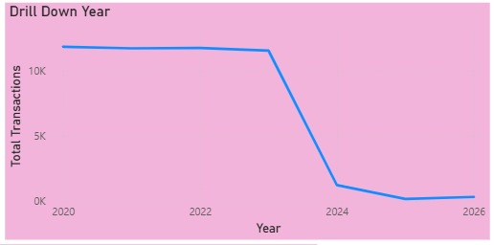
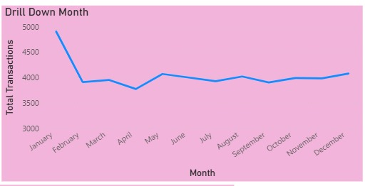
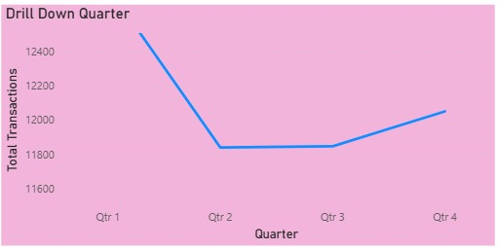
Drill-Through Feature
Drill-through is another interactive feature in Power BI that allows users
to move from a summary visual to a separate report page containing more
detailed information about a selected item.
For example, a user may right-click a transaction category in the main
dashboard and select the drill-through option to open a detail page filtered for
that category. The detail page can display relevant transaction records, dates,
amounts, and other available fields, depending on how the report has been
configured

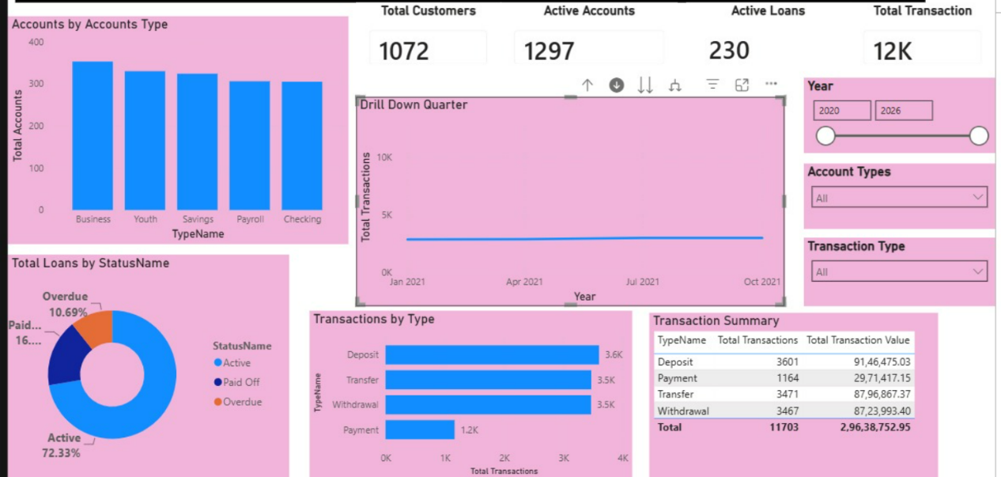
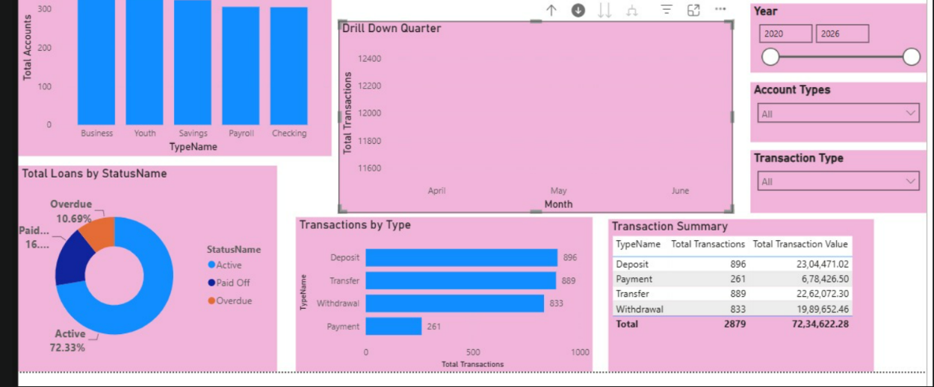

Conclusion

The Financial Transactions and Loans Dashboard demonstrates how
Microsoft Power BI can be used to organize, analyze, and present financial
data in an interactive format. By combining KPI cards, charts, and a summary
table, the dashboard provides an overview of customers, accounts, loans, and
transaction activities.

Each visualization serves a specific purpose. KPI cards summarize the
main financial indicators, the account-type chart compares account
distribution, the monthly line chart highlights transaction trends, and the loan-
status doughnut chart presents the distribution of loans. The transaction-type
chart and summary table provide additional information about transaction
frequency and monetary value.

The addition of drill-down and drill-through features improves the
analytical functionality of the dashboard. Drill-down allows users to move
between different levels of detail within a visual, while drill-through enables
them to navigate to a separate report page containing information related to a
selected data point

